IDR305: Introduction to Economics for Sport Management
Mock Exam: Solutions

Question 1 (15 points)
Answer:
Resource | Production of X | Production of Y | Cost of X (in Y) | Cost of Y (in X) | World price (1X=) | Specializes in (trade)
Machines | 4 | 2 | 0.5Y | 2X | 0.4Y | Y
Workers | 3 | 1 | 0.33Y | 3X | 0.4Y | X
Workers are relatively cheaper at producing X (lower opportunity cost), so they specialize in X; machines are relatively cheaper at producing Y, so they specialize in Y (see table above).
Max X (all resources to X) = 150×4 + 300×3 = 600 + 900 = 1500X.
Max Y (all resources to Y) = 150×2 + 300×1 = 300 + 300 = 600Y.
Kink point: use workers fully for X (cheapest X-producer) = 900X, remaining Y from machines alone = 300Y → kink at (900, 300).
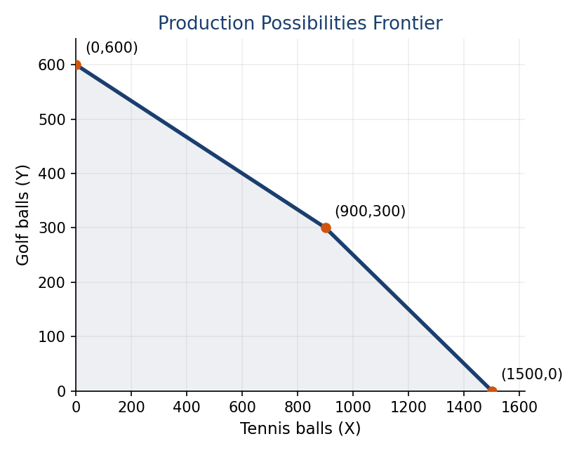
a. PPF runs (0,600) → (900,300) → (1500,0), as shown above. (5 points)
Segment equation (kink to (1500,0)): slope = (0−300)/(1500−900) = −0.5 (machines’ opportunity cost of X). Point-slope form of a line: Y − Y1 = slope × (X − X1), where (X1,Y1) is any known point on the line. Using the kink (900,300) as that point: Y − 300 = −0.5(X−900) → Y = 300 − 0.5(X−900).
b. The kink occurs at Y=300. Since the target Y=250 is below that, the country must be on the lower segment of the PPF (from the kink (900,300) to (1500,0)): Y = 300 − 0.5(X−900). Setting Y=250: 250 = 300 − 0.5(X−900) → 0.5(X−900) = 50 → X−900 = 100 → X = 1000. (3 points)
c. World price: 1X = 0.4Y. Workers’ cost of X (0.33Y) < world price (0.4Y) → workers specialize in X. Machines’ cost of X (0.5Y) > world price (0.4Y) → machines should NOT produce X; their cost of Y (2X) is below the world price of Y (1/0.4 = 2.5X) → machines specialize in Y. The country produces exactly at the kink: 900X and 300Y. (4 points)
d. The country needs to consume 1000X but only produces 900X → it must import 100X, costing 100×0.4 = 40Y. It keeps 300 − 40 = 260Y. Consumption = (1000X, 260Y). (3 points)

Question 2 (15 points)
Answer:
a. Equilibrium: QD=QS → 24−2p = 4p → 24 = 6p → p = 4, Q = 16. (4 points)
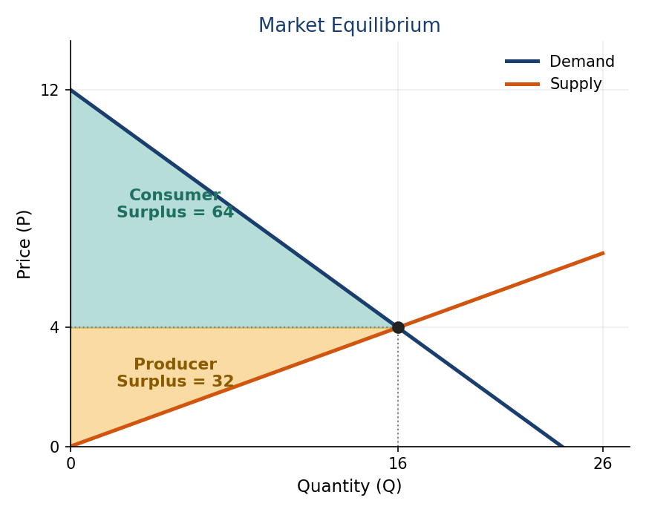
b. See graph above: demand hits the price axis at P=12 (Q=0) and the quantity axis at Q=24 (P=0); supply passes through the origin; both cross at the equilibrium point (16, 4). (6 points)
c. Producer surplus = ½ × 4 × 16 = 32. (2 points)
d. Consumer surplus = ½ × (12−4) × 16 = ½ × 8 × 16 = 64. (2 points)
e. Total social welfare = 32 + 64 = 96. (1 point)

Question 3 (15 points)
Answer:
TP (Q) | L | MP | FC | VC | TC | MC | ATC | AVC
0 | 0 |  | 30 | 0 | 30
1 | 3 | 0.33 | 30 | 45 | 75 | 45 | 75 | 45
2 | 6 | 0.33 | 30 | 90 | 120 | 45 | 60 | 45
3 | 9 | 0.33 | 30 | 135 | 165 | 45 | 55 | 45
4 | 13 | 0.25 | 30 | 195 | 225 | 60 | 56.25 | 48.75
5 | 18 | 0.2 | 30 | 270 | 300 | 75 | 60 | 54

a. VC = 15×L; TC = VC+FC; MC = ΔVC/ΔQ; ATC = TC/Q; AVC = VC/Q (table above). (7 points)
b. Minimal short-term price = min AVC = 45 (at Q=1, 2, or 3). (2 points)
c. Minimal long-term price = min ATC = 55 (at Q=3). (2 points)
d. Produce where MC = P = 75. MC = 75 at Q=5 → the firm produces 5 units. (2 points)
e. Short-run profit = P×Q − VC = 75×5 − 270 = 375 − 270 = 105. (1 point)
f. Long-run profit = P×Q − TC = 375 − 300 = 75. (1 point)

Question 4 (10 points)
Answer:
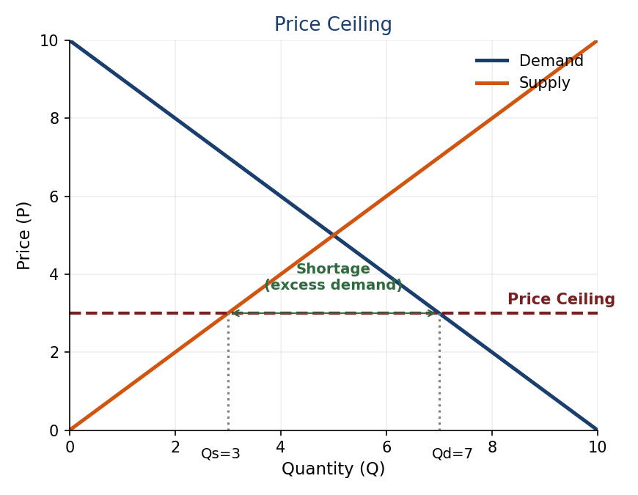
a. A price ceiling set below equilibrium creates a shortage (excess demand): quantity demanded exceeds quantity supplied, since buyers want to buy more at the lower price than suppliers want to sell. (5 points)
b. Example: a league-imposed salary cap limits total team spending on player wages, keeping salaries below what an unrestricted market would otherwise pay. (3 points)
c. Similar: both set a legal maximum price that cannot be exceeded, and both create a shortage on the relevant side of the market (more demanded than supplied) if binding. Different: a salary cap targets one labor submarket (a league) and is usually set and enforced by the league itself rather than a government, and is typically paired with a salary floor at the other end, something an ordinary price ceiling like rent control does not have. (2 points)

Question 5 (10 points)
Answer:
L | TP A | MP A | VMP A (×4) | TP B | MP B | VMP B (×1)
1 | 5 | 5 | 20 | 6 | 6 | 6
2 | 9 | 4 | 16 | 11 | 5 | 5
3 | 12 | 3 | 12 | 15 | 4 | 4
4 | 14 | 2 | 8 | 18 | 3 | 3
5 | 15 | 1 | 4 | 20 | 2 | 2
6 | 15 | 0 | 0 | 21 | 1 | 1

Ranking all VMPs in descending order: 20(A1), 16(A2), 12(A3), 8(A4), 6(B1), 5(B2), 4(A5 and B3 tied), 3(B4), 2(B5), 1(B6), 0(A6).
Taking the top 7 (with the 7th slot a tie at VMP=4): either “5 workers in A, 2 in B” or “4 workers in A, 3 in B”, both combined-VMP-maximizing allocations are valid, since the 7th worker’s VMP is 4 either way.
a. 5 workers in Field A and 2 in Field B (or equivalently, 4 in Field A and 3 in Field B). (6 points)
b. The marginal (7th) worker’s VMP = 4, so the market wage = 4. (4 points)

Question 6 (10 points)
Answer:
FV(Option 1) = 2000×1.04×1.05×1.07 = 2000×1.16844 = 2336.88 NOK.
FV(Option 2) = 1000×(1.04×1.05×1.07) + 1000×(1.05×1.07) = 1000×1.16844 + 1000×1.1235 = 1168.44 + 1123.50 = 2291.94 NOK.
FV(Option 3) = 2000×(1.05×1.07) = 2000×1.1235 = 2247.00 NOK.
Option 1 has the highest Future Value (2336.88 NOK), because investing the full sum as early as possible lets it compound over the greatest number of years. Money invested earlier is always worth more at a fixed future date, all else equal. (10 points)

Question 7 (10 points)
Answer:
a. The number of ways to choose 4 balls out of 14, unordered, without replacement: C(14,4) = (14×13×12×11)/(4×3×2×1) = 24024/24 = 1001. One specific combination (11-12-13-14) is deliberately left unassigned to any team, to round the usable pool down to a clean 1,000; if that exact combination is drawn live, the draw is simply redone. (4 points)
b. Probability = 140/1000 = 14%. (1 point)
c. The Salary Cap ($112.4M in the example used in class) and the Tax Level ($136.6M) define three zones: (1) below the cap: full flexibility to sign free agents with cap space; (2) between the cap and the tax level: the team is “over the cap” but faces no financial penalty, only fewer tools to sign players (e.g. only the mid-level exception); (3) above the tax level: the team pays the luxury tax, a real, escalating dollar penalty on every dollar spent, which is then redistributed to teams below the tax line. (5 points)

Question 8 (8 points)
Answer:
a. The Squad Cost Ratio caps a club’s combined spending on player/coach wages, transfer amortization, and agent fees, as a percentage of the club’s revenue (phased in: 90% → 80% → 70%, permanent from 2025/26). (3 points)
b. 190/250 = 0.76 = 76%, which is above the 70% permanent threshold → the club is NOT compliant. (3 points)
c. Because the ratio is tied to each club’s OWN revenue, clubs that already earn the most can spend far more in absolute terms and still comply, while smaller, ambitious clubs are constrained exactly when they would need to spend to break into the elite. Critics (e.g. Peeters & Szymanski) argue this anchor the existing hierarchy rather than promoting competitive balance. (2 points)

Question 9 (7 points)
Answer:
a. Monopsony power exists when there is effectively a single (or dominant) buyer of a type of labor. Before Bosman (1995), a football club retained rights over a player even after his contract expired, he could not simply leave for free, giving clubs buyer-side market power over players’ labor. (4 points)
b. Wages would be expected to RISE. Removing the clubs’ monopsony power means players can now sell their labor on a more competitive market (several clubs able to bid for a free agent), pushing wages up toward the competitive level that monopsony power had previously held them below. (3 points)

